Title (Flush center, 12 points)

Taro Satoh¹, Ichiro Tanaka¹, Jiro Suzuki¹, and Mary White²
(¹Graduate School of Engineering Kobunshi University, 3-10-9 Irifune, Chuo-ku Tokyo 104-0042, Japan ² Polymer Chemical Co., 10-5-9 Hacchobori, Chuo-ku Tokyo 104-0032, Japan)
¹Tel: +81-3-5540-3770, Fax: +81-3-5540-3737, E-mail: kobunshi@spsj.or.jp

Start writing the text here ………………………………………………………… ………

[The number of pages of the manuscript]
If you entry a poster presentation, please make your manuscript by 1 page.
If you entry an oral presentation, please make your manuscripts by 1 page.

[File format and Size]
The Manuscript should be limited on Japanese A4(210mm wide x 297mm high) size by PDF file.
Please leave a margin of 25mm on the top, bottom, right and leftside of the file.
It means your abstract will be shown in 247mm high x 160mm wide. The abstract will be appeared in color.

[Layout for abstract]
The title should be 12 points and placed in the center, other texts should be 10 points.
We'll recommend to use “Arial”, “Times New Roman”, “Courier” fonts.

Do not describe your presentation number in your manuscript.
The number will be shown in the upper corner in your manuscript by SPSJ.

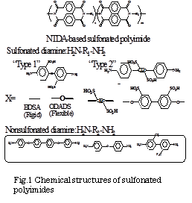
Please write all explanations of a figure, a table and a picture and characters in English.
We'll stick and recommend about 300 dpi to the resolution of the crowded picture and picture.

[Abstract and Keyword]
Don't describe in the manuscript and when submitting your manuscript, please input to a fixed space of the web.
Abstract and Keyword are opened by preprints on web and are also used for a search.

[PDF file creation]
Please make a PDF file within 1.0Mbyte.
The file must be named “your number.pdf”. Do not cut off an extension(.pdf).
Choose Security for your PDF file “NON”.
Please bury the "font".

